What is Big O Notation?
Big O Notation describes the upper bound of an algorithm’s running time. It helps us understand how an algorithm scales with input size n.

Notation | Meaning | Example
O(1) | Constant time | Accessing array[i]
O(n) | Linear time | Linear search
O(log n) | Logarithmic time | Binary search
O(n²) | Quadratic time | Bubble sort

Best, Average, and Worst Case

Case | Linear Search | Binary Search (sorted array)
Best | O(1) (first item) | O(1) (middle item)
Average | O(n/2) → O(n) | O(log n)
Worst | O(n) | O(log n)

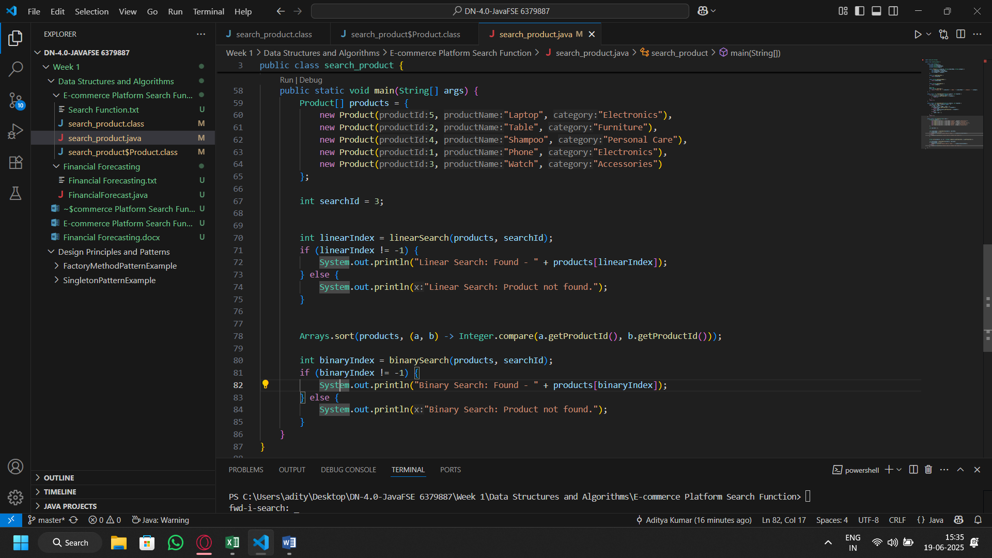
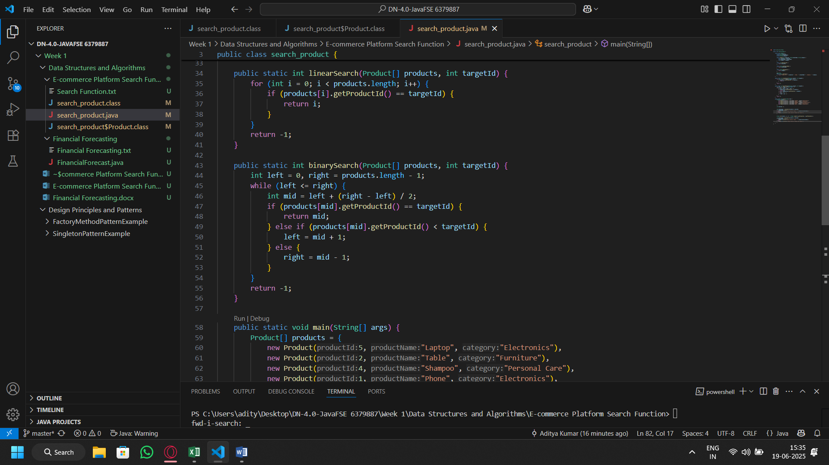
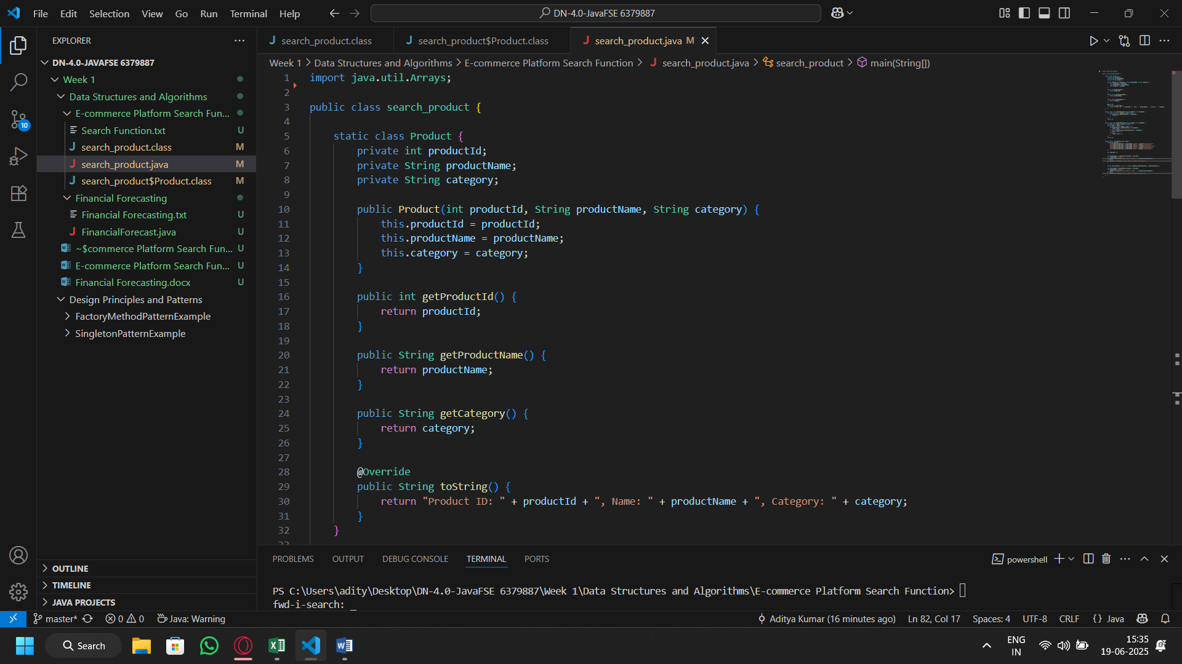
Code:

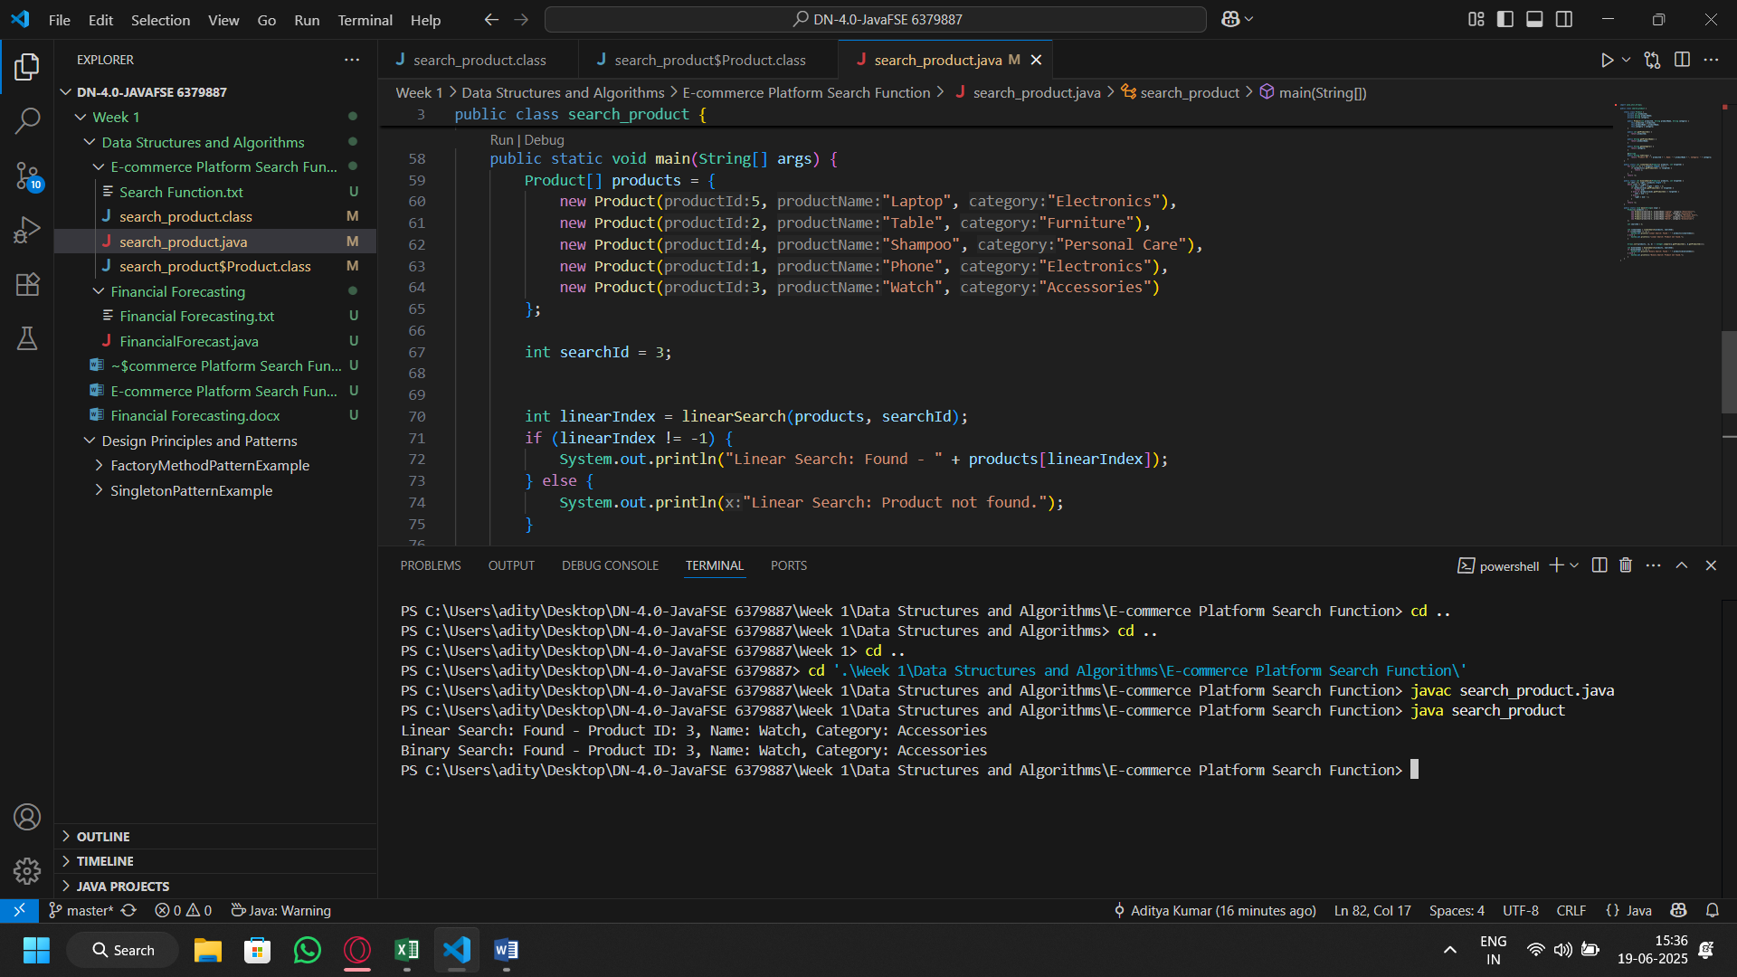
Output:

